Cisco ASA with AnyConnect VPN and Azure MFA Configuration for RADIUS

Published October, 2015

Version 1.0

Azure Multi-Factor Authentication seamlessly integrates with your Cisco® ASA VPN appliance to provide additional security for Cisco AnyConnect® VPN logins and portal access. Multi-factor authentication (MFA) is combined with standard user credentials to increase security for user identity verification.

Azure supports several multi-factor authentication methods for the RADIUS protocol. Each method is a challenge-response mechanism that occurs after primary authentication with standard user credentials.

* Phone call – users receive a phone call with instructions on how to complete login.
* Text message – users receive an SMS message that contains a verification code. Azure supports two options for RADIUS:
* One-way messaging requires users to enter a sent verification code in a prompt on the login page.
* Two-way messaging requires users to send the verification code by text message reply.
* Mobile app – users receive a push notification from client software installed on a smart device, like a phone or tablet. The Azure Authenticator app is available for Windows Phone, iOS, and Android.
* OATH token – users have a token that generates a verification code which is then entered in a prompt on the portal login page. Azure supports two options:
* Third-party OATH tokens can be imported to the system and synced with user accounts. A common example is a hardware token like a key fob.
* The Azure Authenticator app for smart devices can serve as an OATH token to generate verification codes for Windows Phone, iOS, and Android devices.

This guide will help you to configure Azure Multi-Factor Authentication (MFA) server and Cisco ASA to use the RADIUS protocol for AnyConnect VPN authentication.

# Overview

The Azure Multi-Factor Authentication server acts as a RADIUS server. The Cisco ASA appliance acts a RADIUS client. The RADIUS server works as a proxy to forward requests that use multiple authentication factors to a target directory service. The proxy receives a response from the directory, which it sends to the RADIUS client. Access is granted only when both the user credentials (primary authentication) and the MFA challenge succeed. See the diagram in Figure 1 for reference.



Figure 1

The diagram above represents the logical process flow for MFA. The user experience for MFA is fairly similar to traditional login. See Figure 2 for a description of the workflow.



Figure 2

# Guide Usage

The information in this guide explains the configuration common to most deployments. It is important to note two things:

* Every organization is different and may require additional or different configuration.
* Some configuration may have other methods to accomplish the same task than those described.

Information is based on the conditions described in the Prerequisites and Components sections. The Conventions section provides usage information and details about the environment used for this guide.

## Prerequisites

The following conditions are required to set up Azure MFA:

* An MFA server installed on a system with either:
* Windows Server 2003 or higher.
* Windows Vista or higher, that has Users Portal and Web Service SDK services installed.
* A Cisco ASA appliance with Adaptive Security Device Manager (ASDM) access and default AnyConnect client configuration to use for MFA.

NOTE: Default configuration can be configured by running the AnyConnect VPN wizard from the ASDM console.

* Cisco AnyConnect client software installed on all clients that connect remotely to the network.
* Familiarity with the following technologies:
* RADIUS configuration
* VPN appliance administration

Deployments offering the mobile app authentication option will also require:

* MFA deployed on systems with Windows Vista or higher require the Mobile App Web service to be installed.
* A user device with the Azure authentication application installed.

## Components

The following conditions reflect the assumptions and scope for information described in this guide.

* The Azure MFA server is installed on a domain-joined Windows 2012 R2 server.
* One Azure MFA server will be configured for RADIUS.
* One Cisco ASA appliance is configured.

## Conventions

Information is based on the following conditions.

* The guide was written using a Cisco ASA 5506 appliance.
* Documentation will refer to the Cisco ASA appliance as the VPN appliance, or just appliance.
* The Azure Multi-Factor Authentication Server is referred to as the MFA server.
* Active Directory (AD) is the directory service used for authentication.
* Users will be imported from AD.
* A default token method will be configured.
* The OATH token method uses verification codes generated by the Azure Authentication app.

NOTE: While Azure MFA includes the option use Personal Identification Numbers (PINs) as an additional factor to the supported authentication methods, that configuration is outside the scope of this guide.

# Step 1: Configure Multi-Factor Authentication Server

This topic explains how to configure the MFA server and the on-premises resources it requires. First you will log in to the server where MFA is installed. Next you will configure RADIUS Authentication. Then you will connect MFA to the directory service, after which you will configure a default authentication method. Finally you will import accounts to the MFA Users group.

## Multi-Factor Authentication Server Console

1. Log in to the server where MFA is installed.
2. Open the **Apps** screen.
3. Click the **Multi-Factor Authentication Server** icon:



1. The **Multi-Factor Authentication Server** window opens.

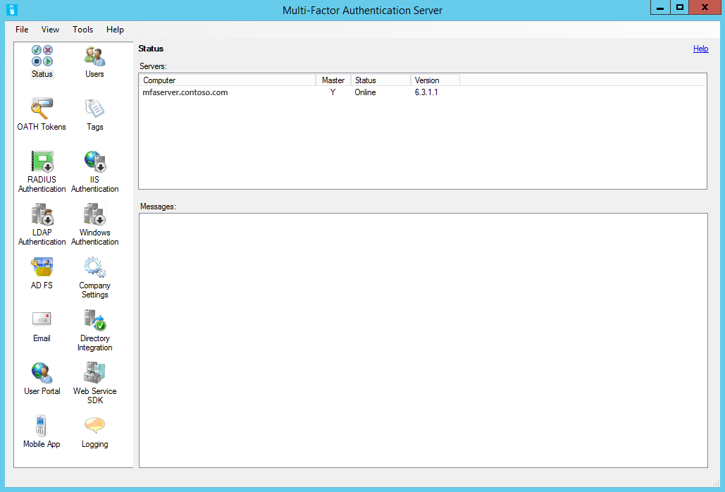

Now you will configure the necessary services.

## RADIUS Authentication

First you will enable RADIUS authentication, and then add the VPN appliance as a client.

1. Click the **RADIUS Authentication** icon.

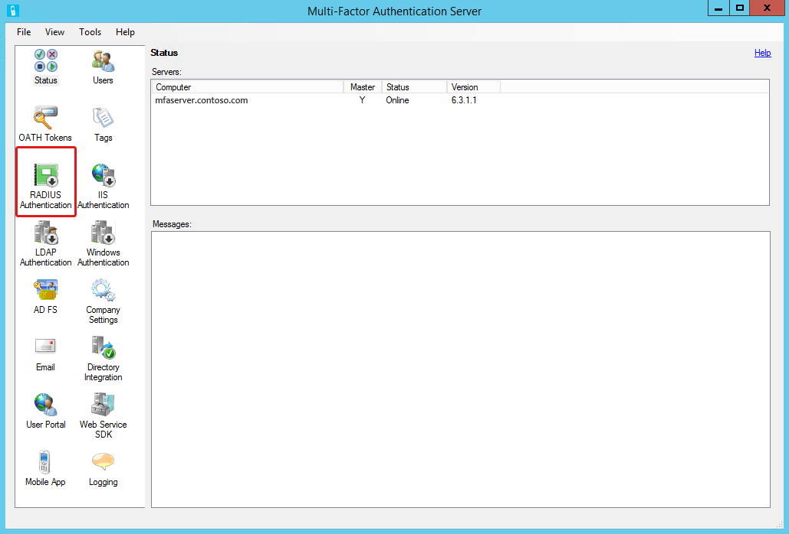

1. When the RADIUS Authentication tool opens, select **Enable RADIUS authentication**.

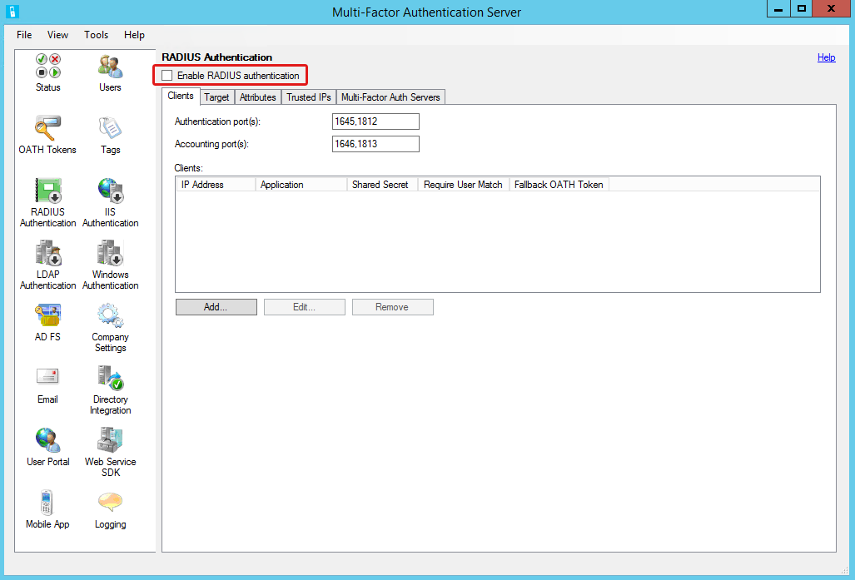

1. Select the **Clients** tab if necessary.

NOTE: Keep track of the port numbers noted for authentication and as you will need them for the VPN appliance configuration. Authentication defaults are 1645 or 1812.

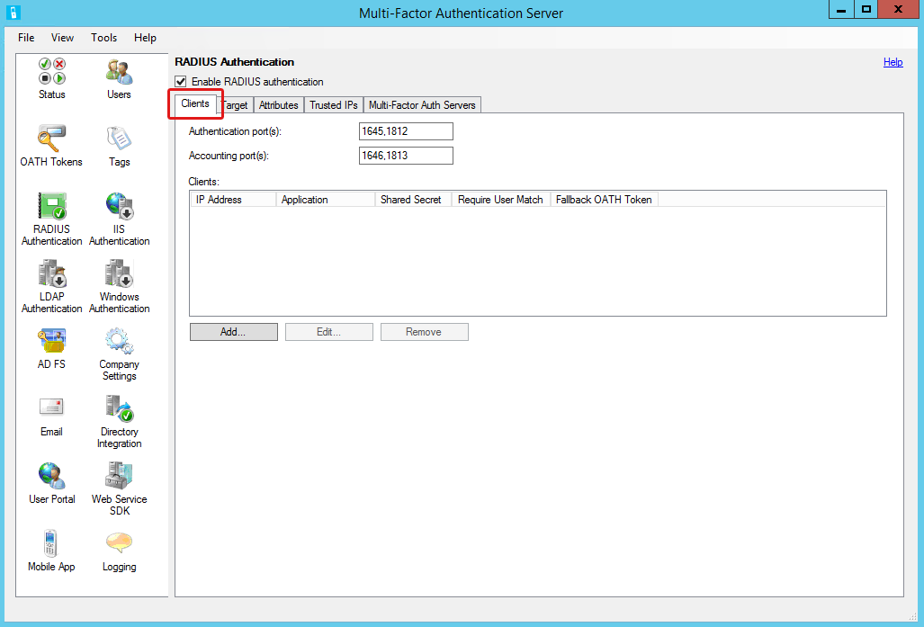

1. Click **Add** to open the **Add RADIUS Client** dialog box.

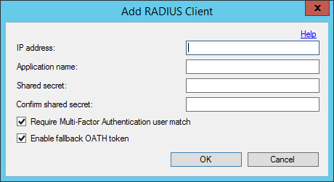

1. Complete the following:
2. **IP address** – enter the VPN appliance address.
3. **Application name** – enter a descriptive name for the VPN appliance.
4. **Shared secret** – create passphrase to secure the RADIUS communication.

NOTE: The shared secret will be configured on both the MFA server and VPN appliance, so keep track of it.

1. **Require Multi-Factor Authentication user match** – select; only users who are included in the MFA Users list will be granted access.

NOTE: This feature provides better control over remote access. If not enabled (unchecked), then only users who are included in the MFA Users list will need to authenticate with MFA. Other domain users will be able to authenticate without MFA.

1. **Enable fallback OATH token** – select to provide an alternate method of authentication in the event the default method times out.

NOTE: This feature only applies when OATH token is not the method assigned to a user account. When invoked, the user will be prompted to authenticate with a hardware token if one is registered for the user account.

1. Select the **Target** tab.

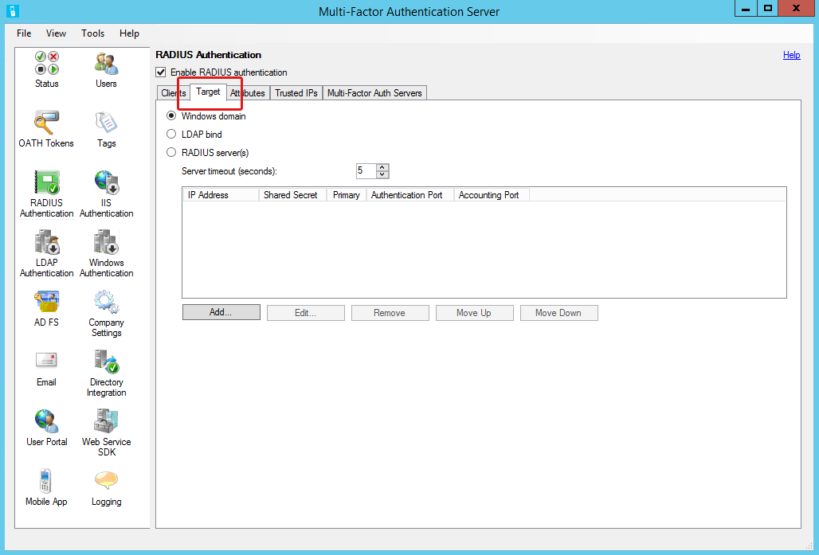

1. Select **Windows Domain**; this will configure the MFA server to use AD for primary authentication.

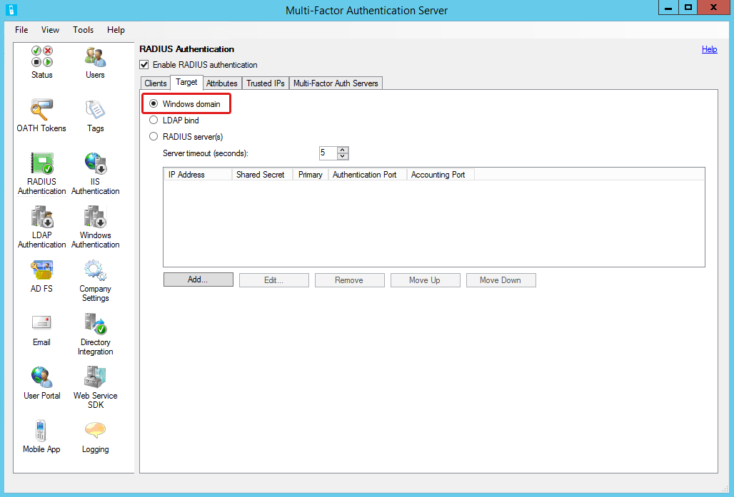

You have completed configuring RADIUS authentication and adding the VPN server as a RADIUS client. Leave the **Multi-Factor Authentication Server** window open for the next task.

## Directory Integration

Now you will connect to the directory service.

1. In the navigation area, click the **Directory Integration** icon.

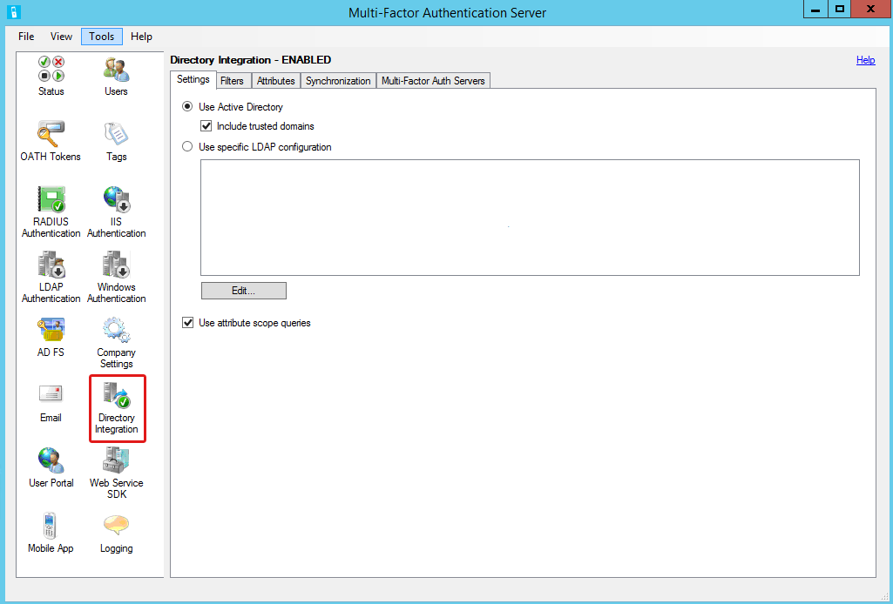

1. When the Directory Integration tool opens, select the **Settings** tab if necessary.

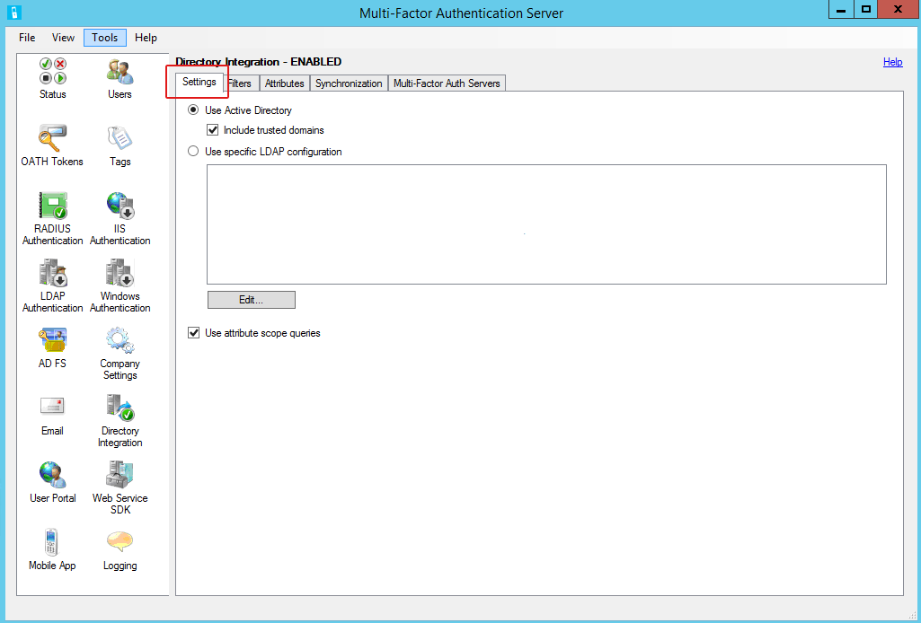

1. Select **Use Active Directory**.

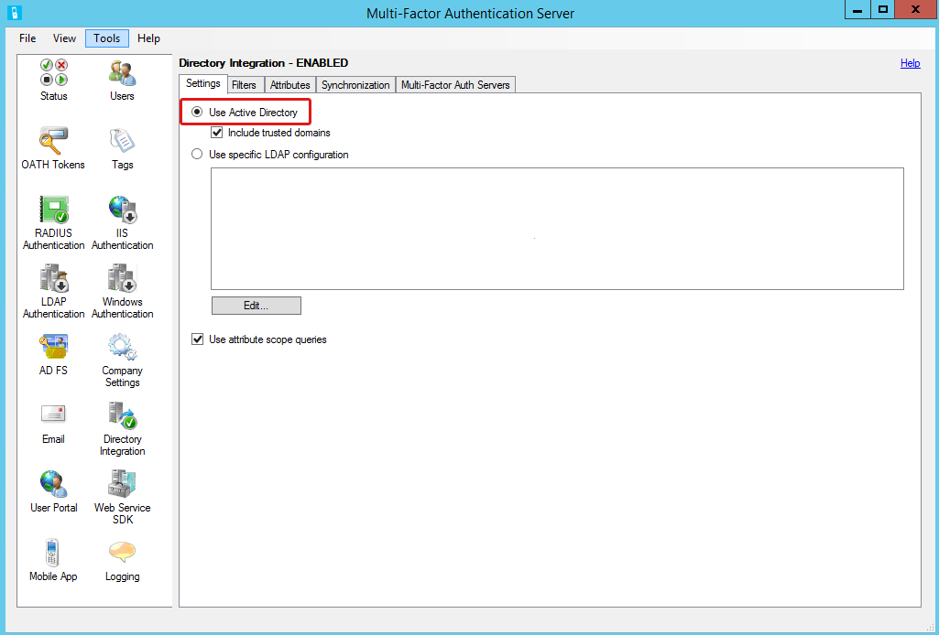

You have completed the MFA server directory service setup. Leave the **Multi-Factor Authentication Server** window open for the next task.

## Default Authentication Method

The instructions below explain how to set a default option for the authentication method that will be automatically assigned to MFA user accounts. A default method is required when user are not allowed to change methods. The feature is optional when users are allowed to change their token methods, and may be more convenient if a majority of users need one method.

### Configure Company Settings

1. In the navigation area, click the **Company Settings** icon:

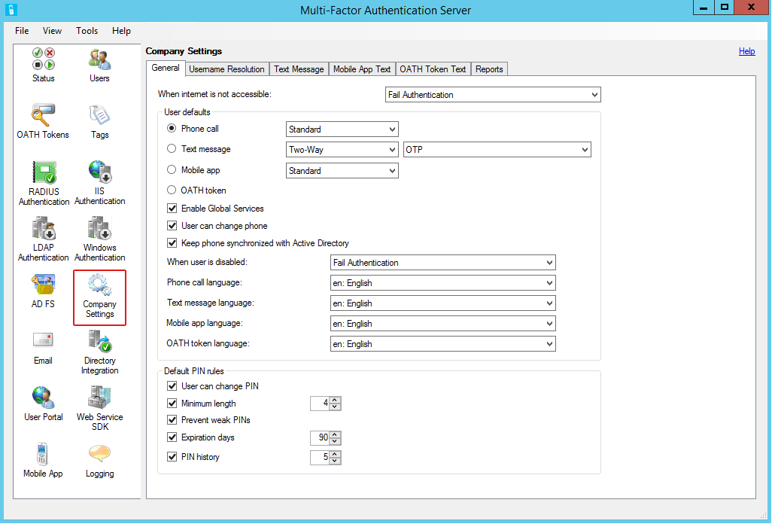

1. When the Company Settings tool opens, select the **General** tab if necessary.

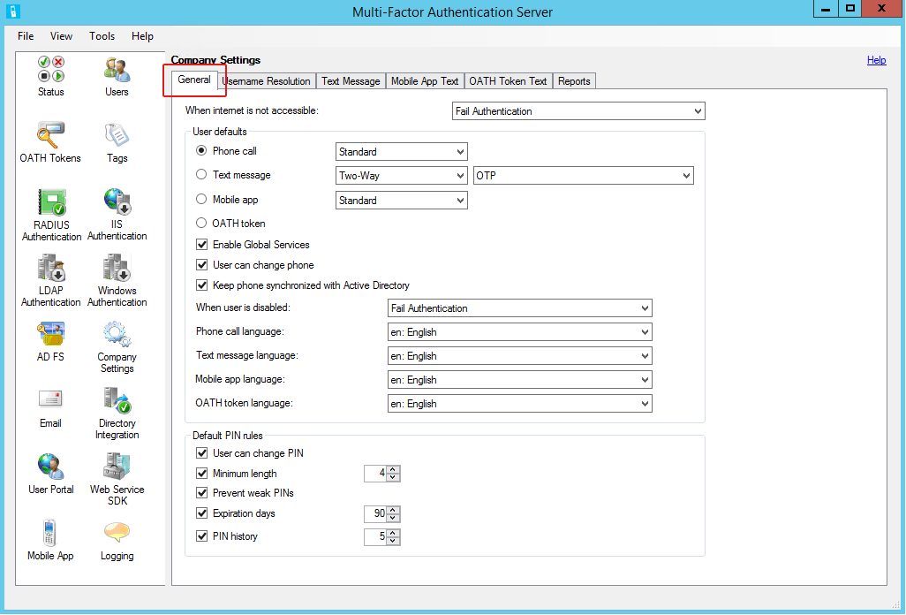

1. Leave default settings except for the following:

* **User defaults** – select one of the options below:
* **Phone call** – select **Standard** from the drop menu:

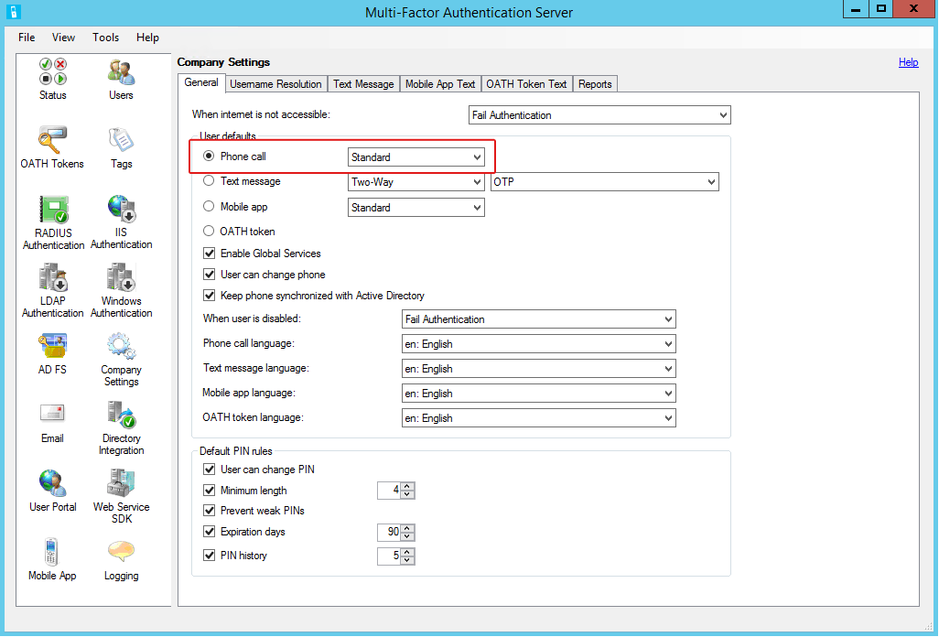

* **Text message** – configure one of the following:
* **One-Way** and **OTP** from the drop menus:

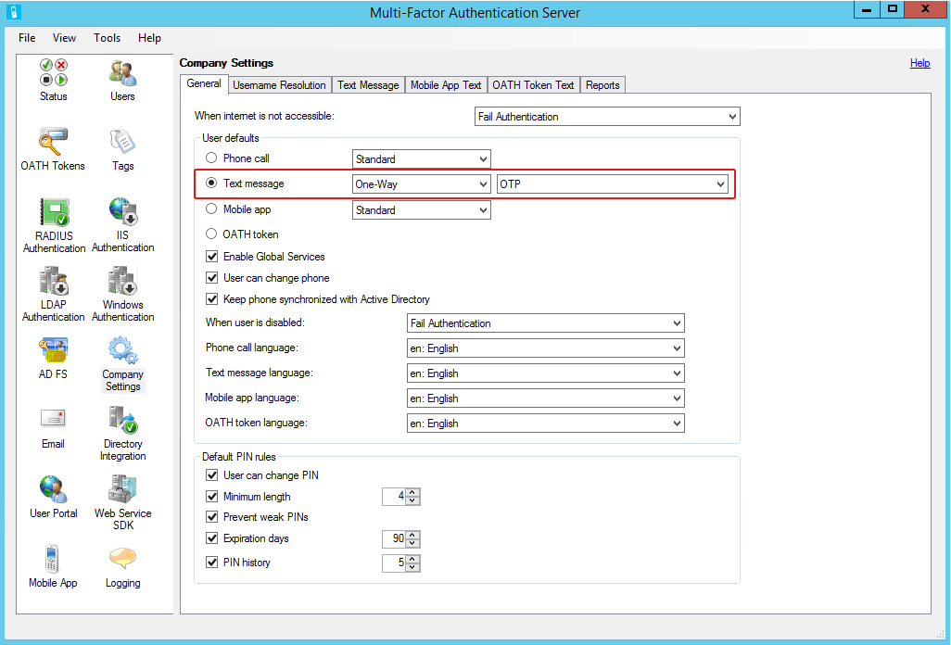

* **Two-Way** and **OTP** from the drop menus:

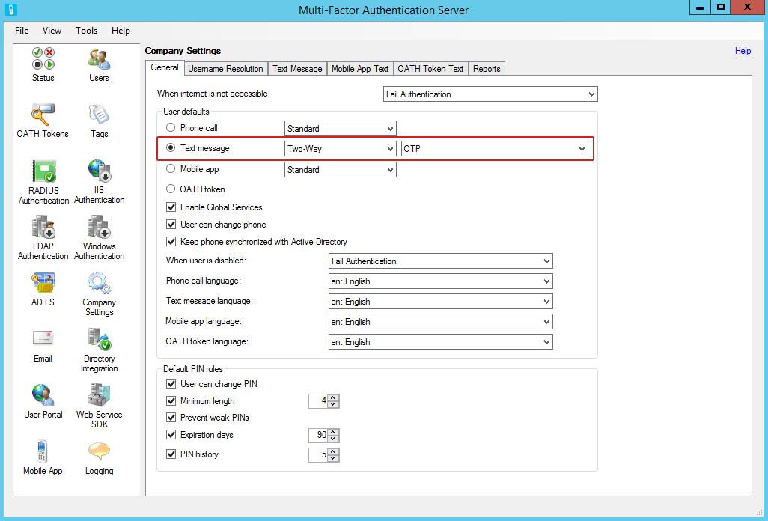

* **Mobile app** – select **Standard** from the drop menu:

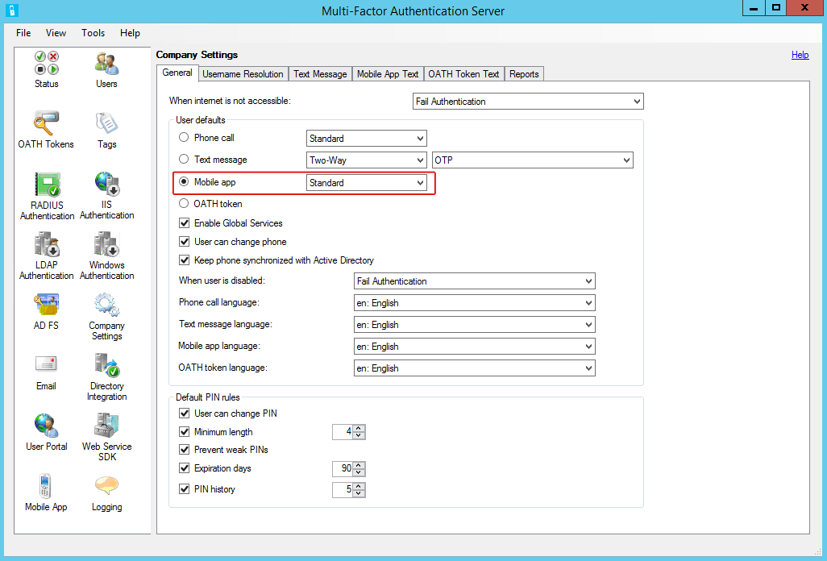

Note: This option will require users to register their devices through the Azure authentication app.

* **OATH token**

NOTE: This guide provides information about using the OATH token method through the Azure Authenticator app. While third-party tokens can be imported through the Multi-Factor Authentication **OATH Tokens** feature, that function is outside the scope of this this guide.

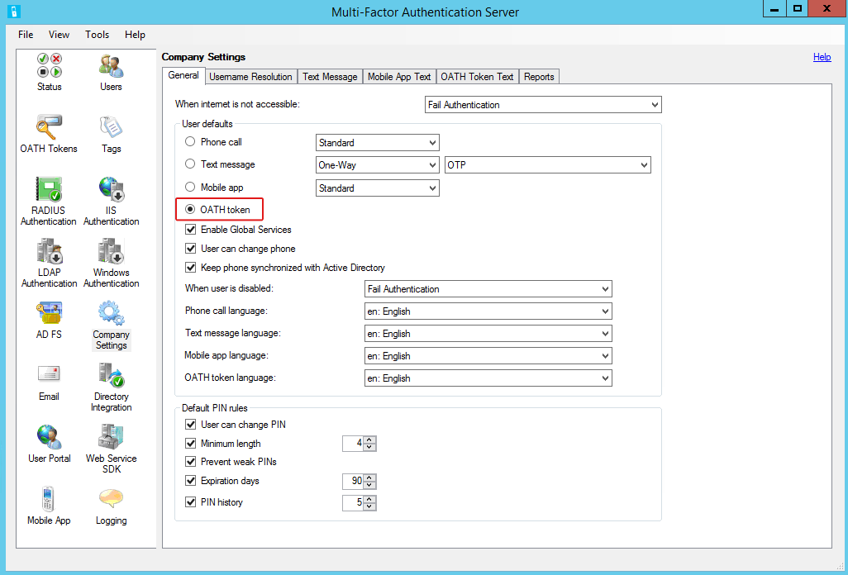

This completes the company information setup to designate the default authentication method for RADIUS Authentication. Leave the **Multi-Factor Authentication Server** window open for the next task.

## MFA Users

When the VPN appliance was configured as a RADIUS client, access was restricted to members of the MFA Users group. This provides more control over remote access, and is a security best practice. Now accounts need to be imported from the directory service.

### Import User Accounts

Theses instructions are for on-demand user import.

1. In the navigation area, click the **Users** icon.

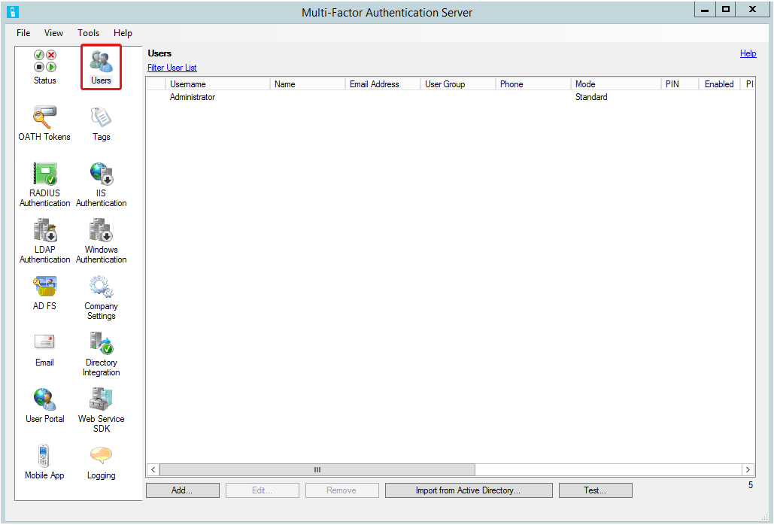

1. When the Users tool opens, Click **Import from Active Directory**.

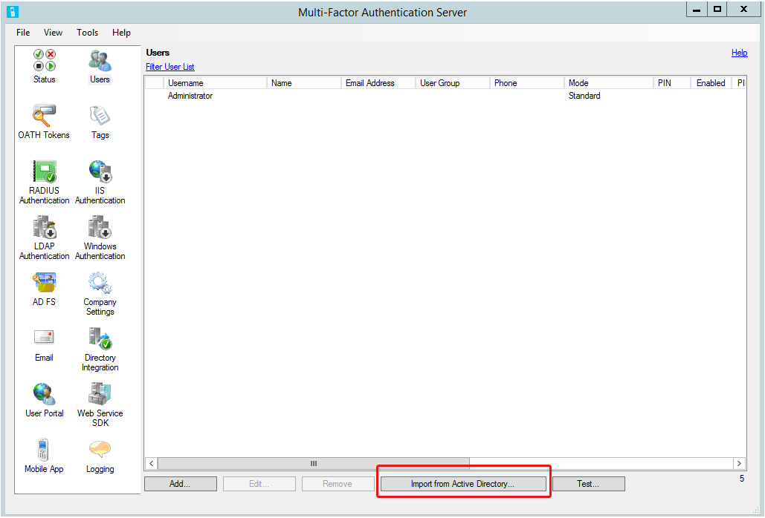

1. On the import screen, select a user group.

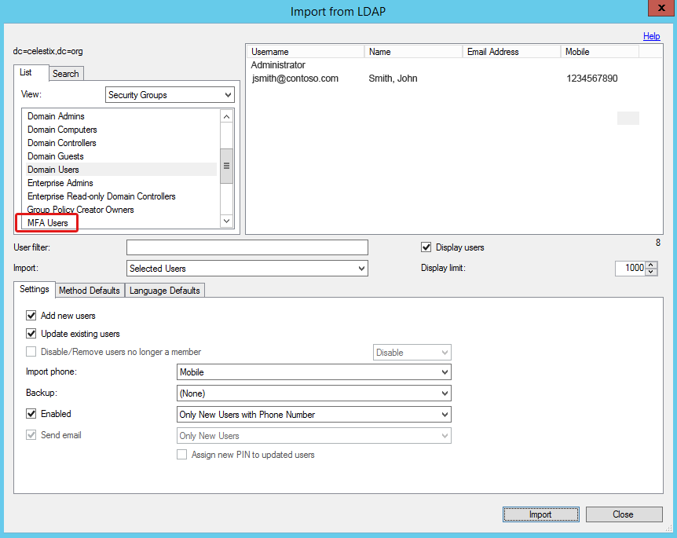

1. Select the user accounts you want to import.

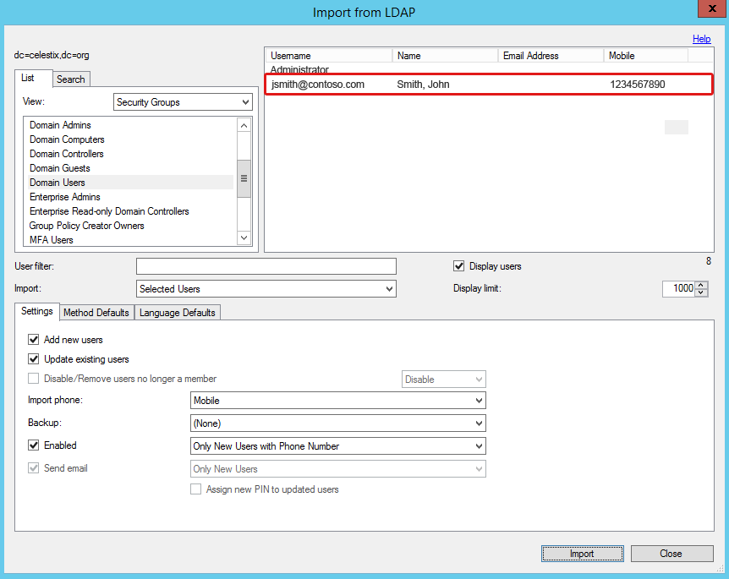

1. Leave the default settings except for the following:
2. Select the **Settings** tab if necessary.

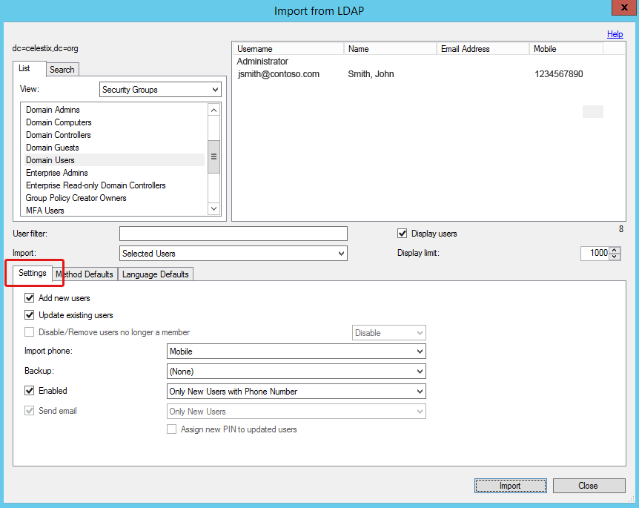

1. In the **Import Phone** drop menu, select **Mobile**.

NOTE: For purposes of this guide we are designating the Mobile attribute for the phone import setting. It is the most common option used for MFA.

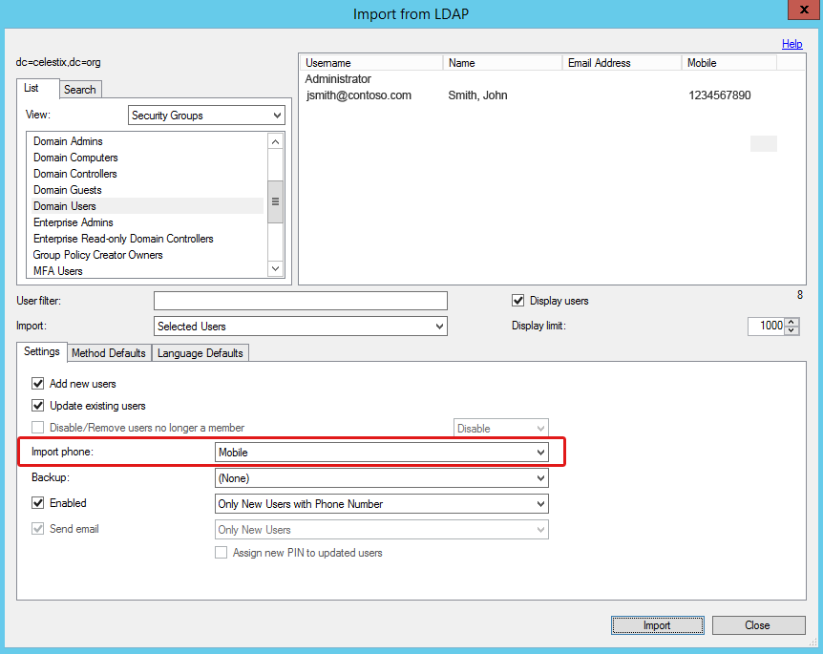

1. Click the **Import** button.

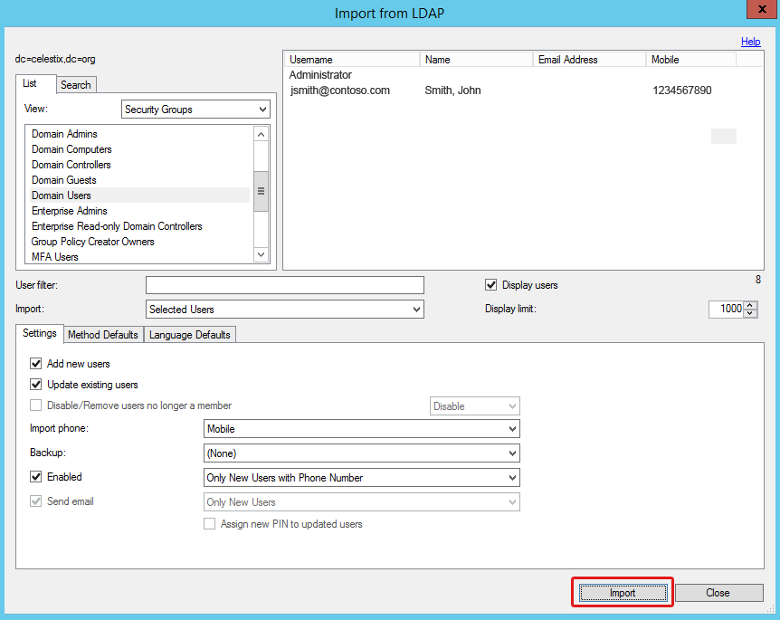

1. Click **OK** in the import success dialog box.

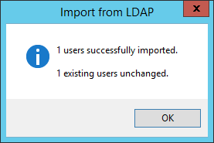

1. Click the **Close** button on the import screen to return to the Users pane.

You have completed MFA server configuration.

# Step 2: Configure the VPN Appliance

Now that the authentication process has been configured to use multiple factors, you need to configure the VPN appliance to connect to the RADIUS server.

## ASDM Console

Configure an authentication server on the VPN appliance that will send RADIUS authentication requests to the Azure MFA server.

First you will configure a server group for the MFA RADIUS server. Next you need a connection profile for AnyConnect to access the RADIUS server. Then you will create a profile to set a custom timeout value to ensure that AnyConnect VPN clients have enough time to log in using MFA.

### Create AAA Server Group

1. Log in to the Cisco ASDM console for the VPN appliance.

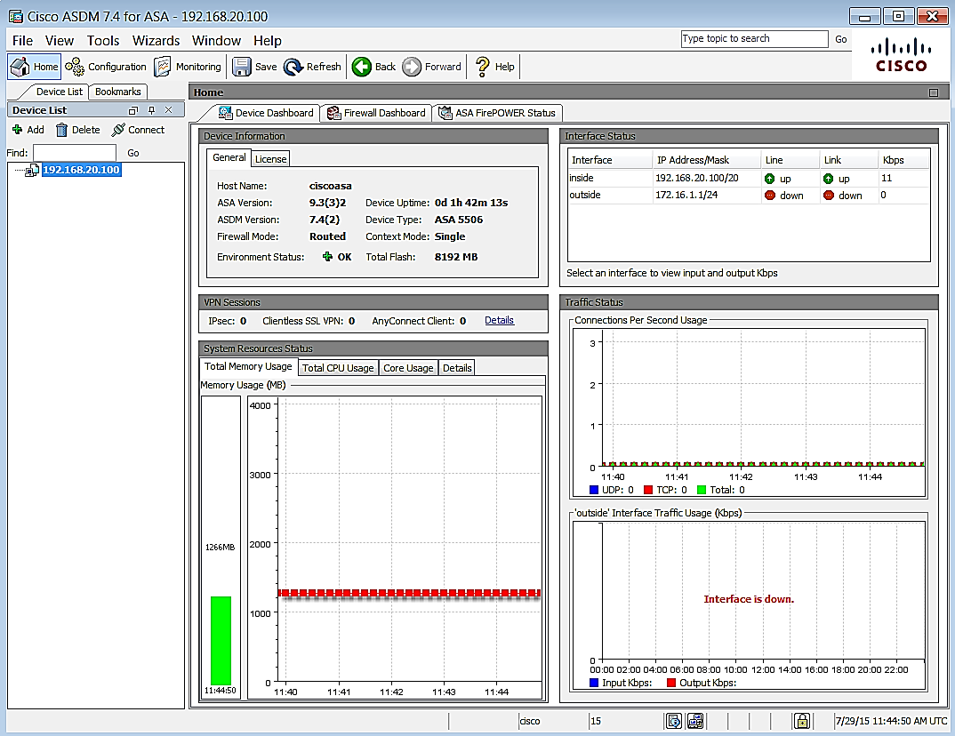

1. Navigate to **Configuration**|**Remote Access VPN**|**AAA/Local users**|**AAA server groups**.

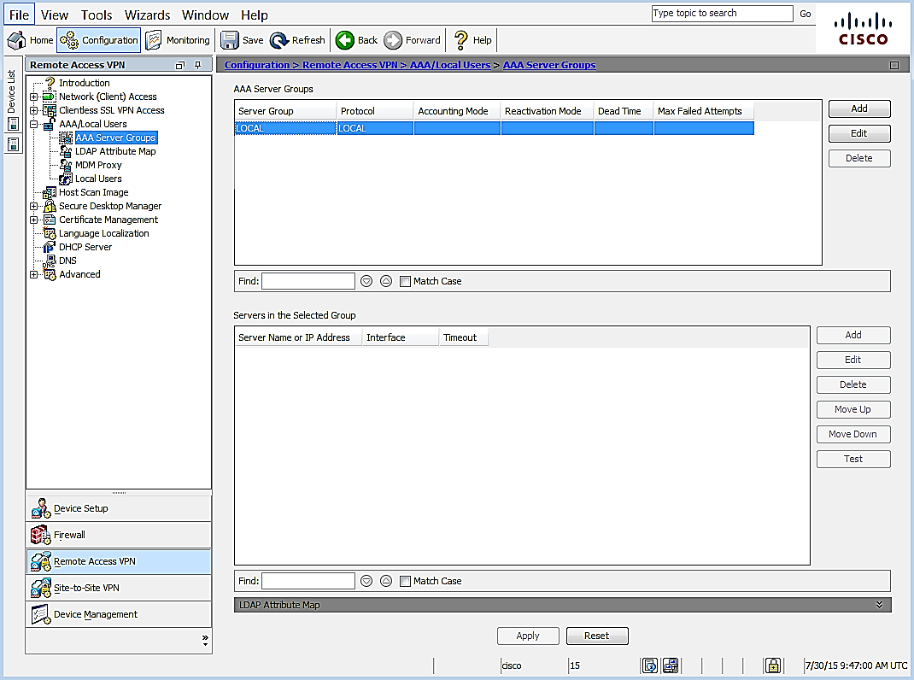

1. Click **Add** to create a new group.

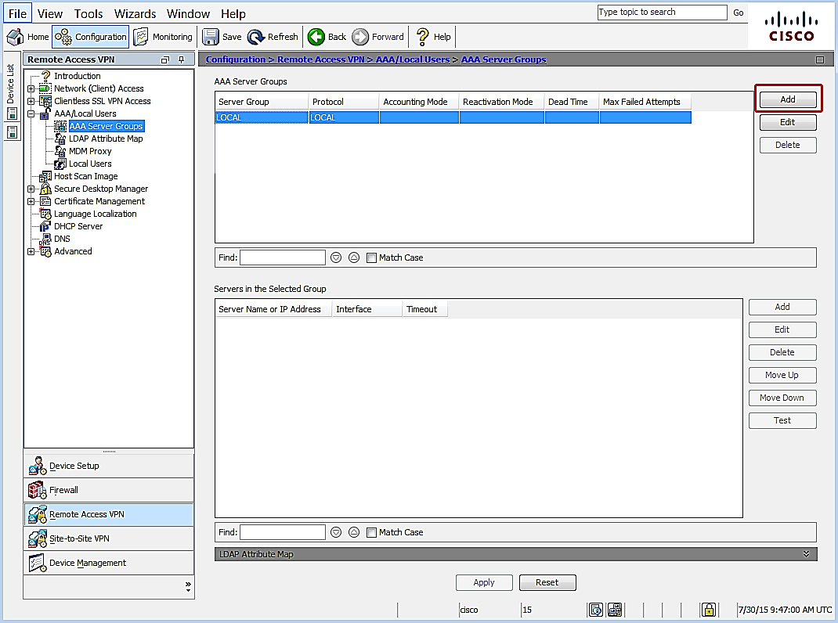

1. The Add a new AAA Server Group dialog opens.

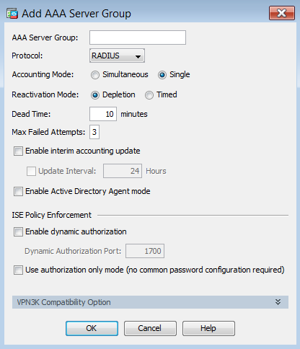

1. Leave the default settings except for the following:
2. **AAA Server Group** – specify a name to identify the group for the MFA server.
3. **Protocol** – select **RADIUS** if necessary.
4. Click **OK**.
5. In the **AAA Server Groups** list, select the server group you just created.

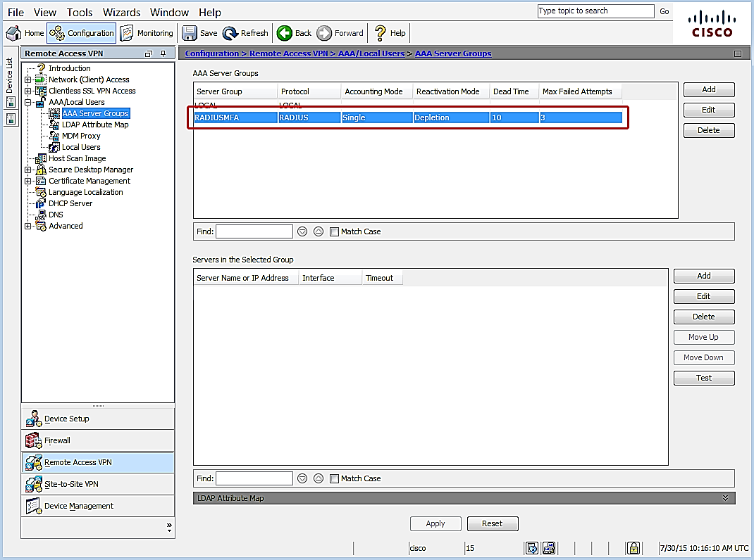

1. In the **Servers in the Selected Group** pane, click **Add**.

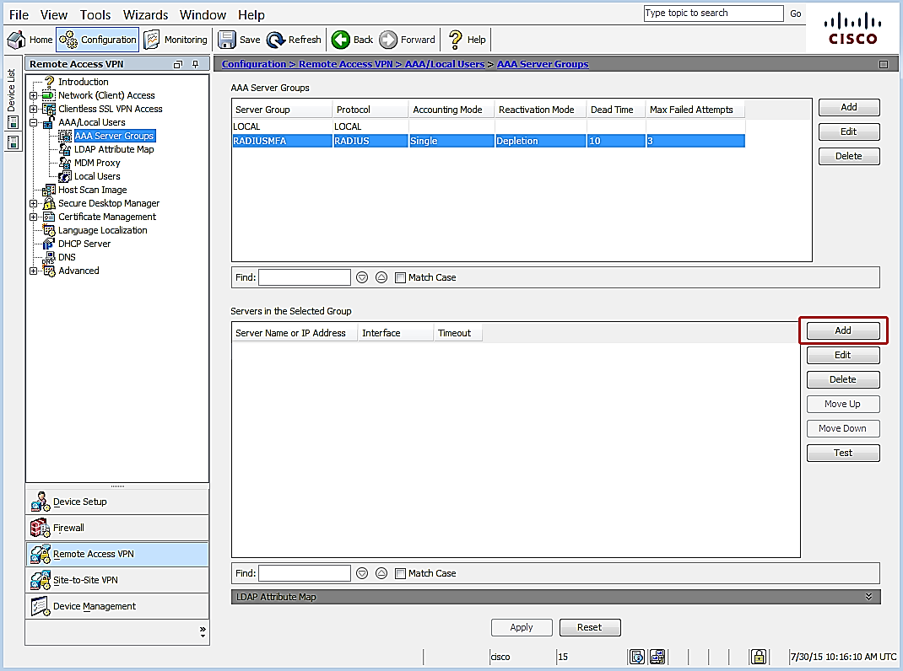

1. The Add AAA Server dialog opens.

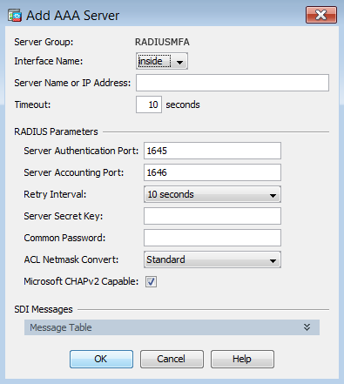

1. Leave the default settings except for the following:
2. **Interface Name** – select the interface that will handle communication with the MFA Server.
3. **Server Name or IP Address** – specify the name or the IP address of the MFA server.
4. **Timeout (seconds)** – it is important to set a sufficient length of time for users to authenticate. 60 seconds is a common duration, but may need to be adjusted. For example, large organizations may need more time to accommodate a higher volume of requests.
5. **Server Authentication port** – enter the port number used for authentication communication on the MFA Server. Defaults are 1812 or 1645.
6. **Server Accounting Port** – enter the port number used for Radius Accounting. Defaults are 1646 or 1813.
7. **Retry Interval** – leave default at 10 Seconds.
8. **Server Secret Key** – enter the security passphrase created to encrypt communication between MFA and the Cisco ASA.
9. **Common Password** – re-enter to passphrase.
10. Click **OK**.
11. Click **APPLY** to save the configuration.

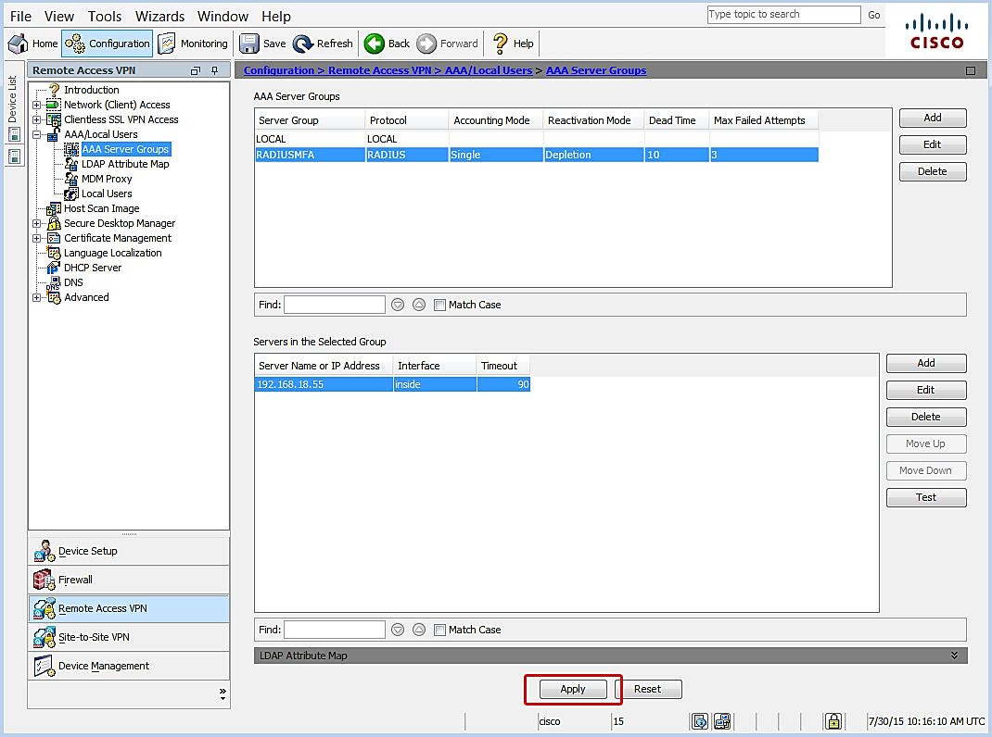

#### Test Configuration

You can test the connection to MFA server to confirm that the connection is correctly configured.

1. Make sure the RADIUS server you created is still selected.
2. Click the **Test** button to open the test tool.

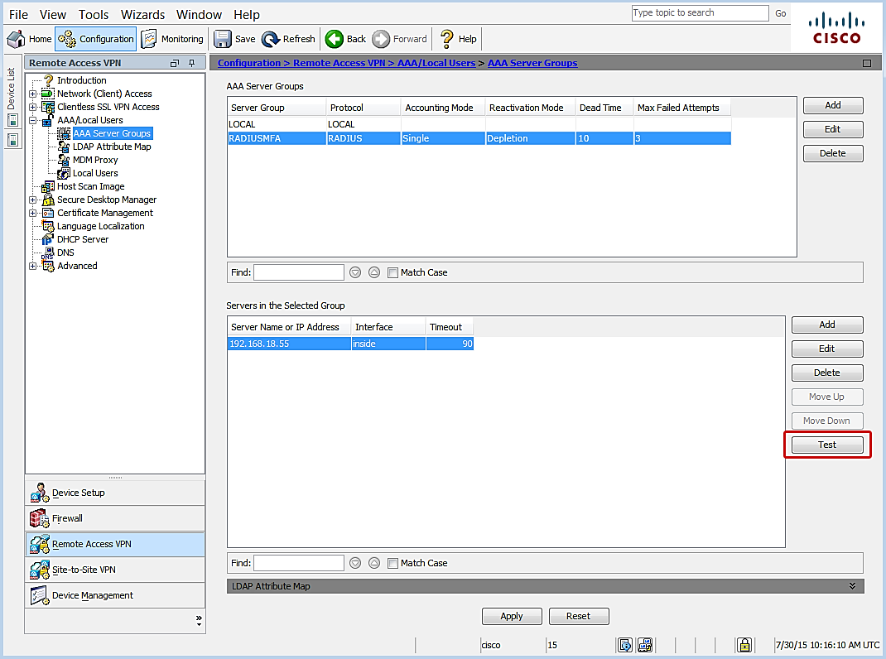

1. Select a test option:

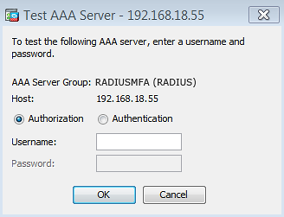 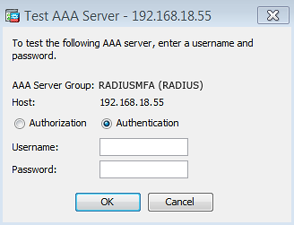

1. Enter credentials for an account that is configured for Azure MFA.
2. Click **OK** and wait for test results to post.

### Enable Connection Profile

1. Navigate **Remote Access VPN**|**Network (Client) Access**|**AnyConnect Connection Profiles**.

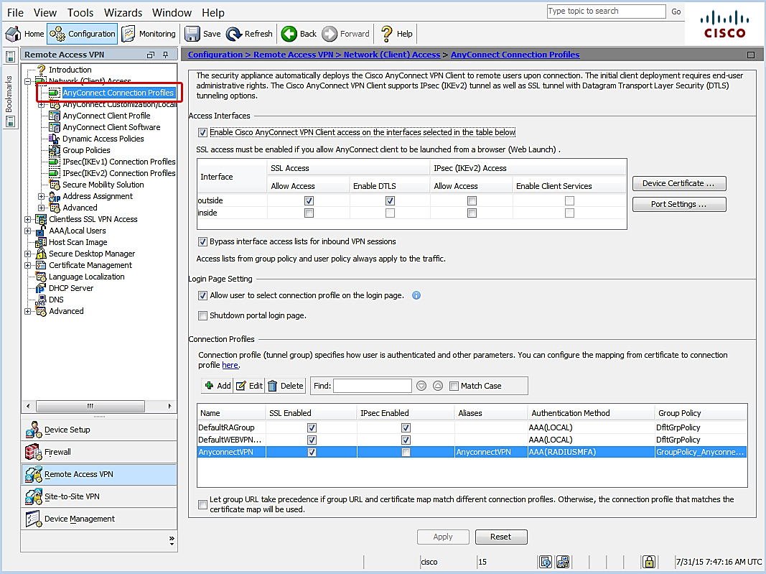

1. Leave default settings, except for the following:
2. **Enable Cisco AnyConnect VPN Client access on the interfaces selected in table below** – confirm checkbox is selected.

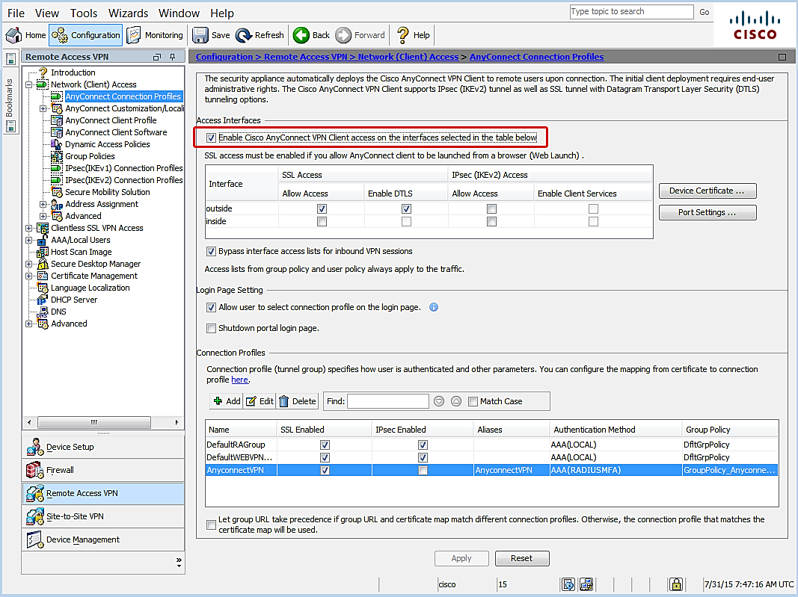

1. Select the appropriate SSL interface access option.

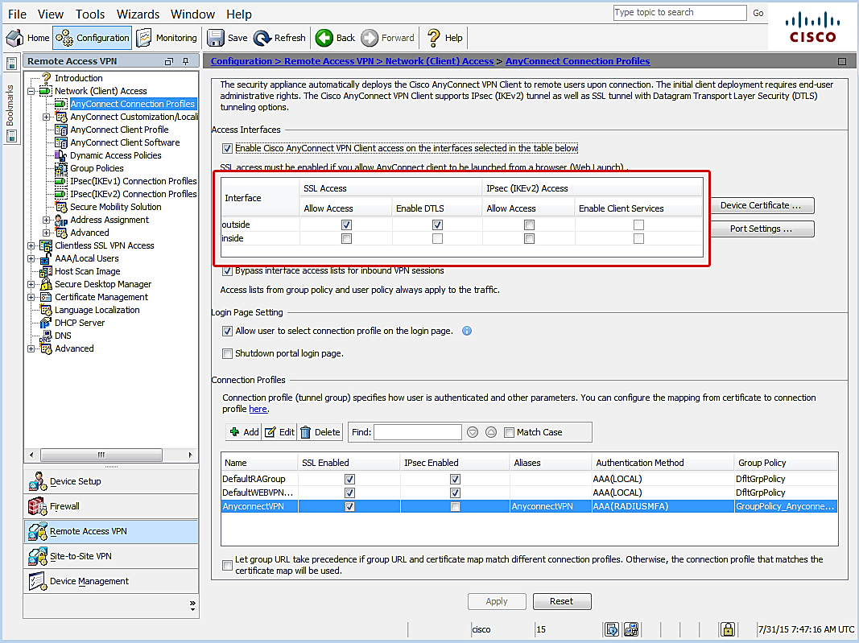

1. **Connection Profiles** – select the AnyConnect VPN profile.

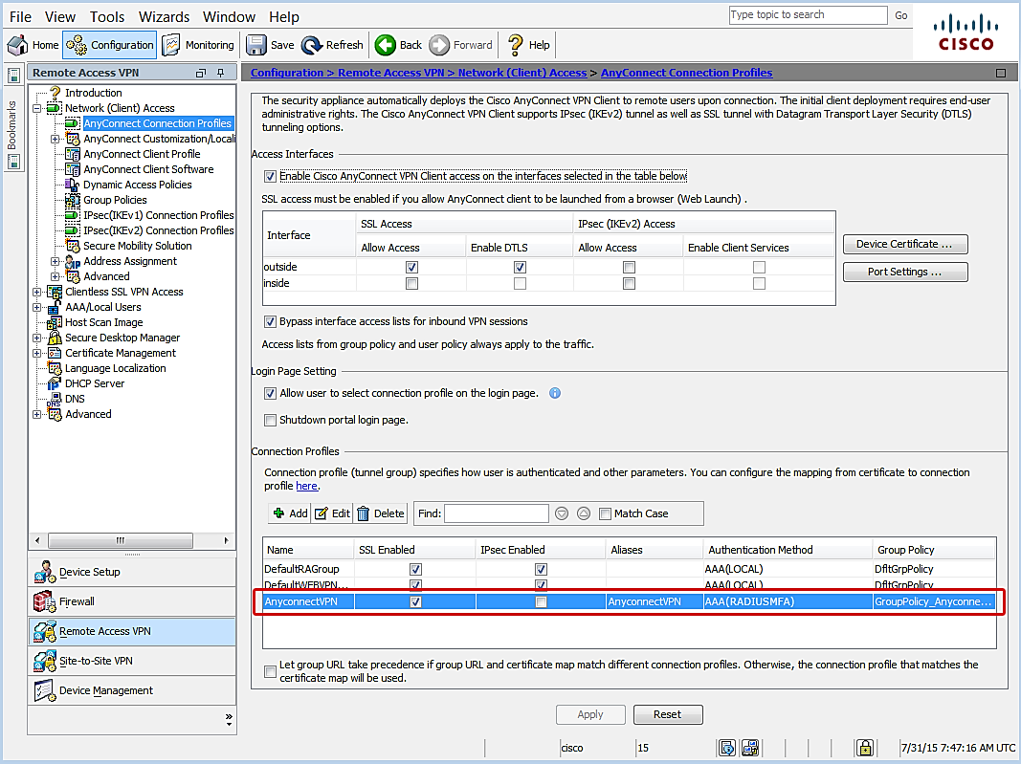

1. Click **Edit**.

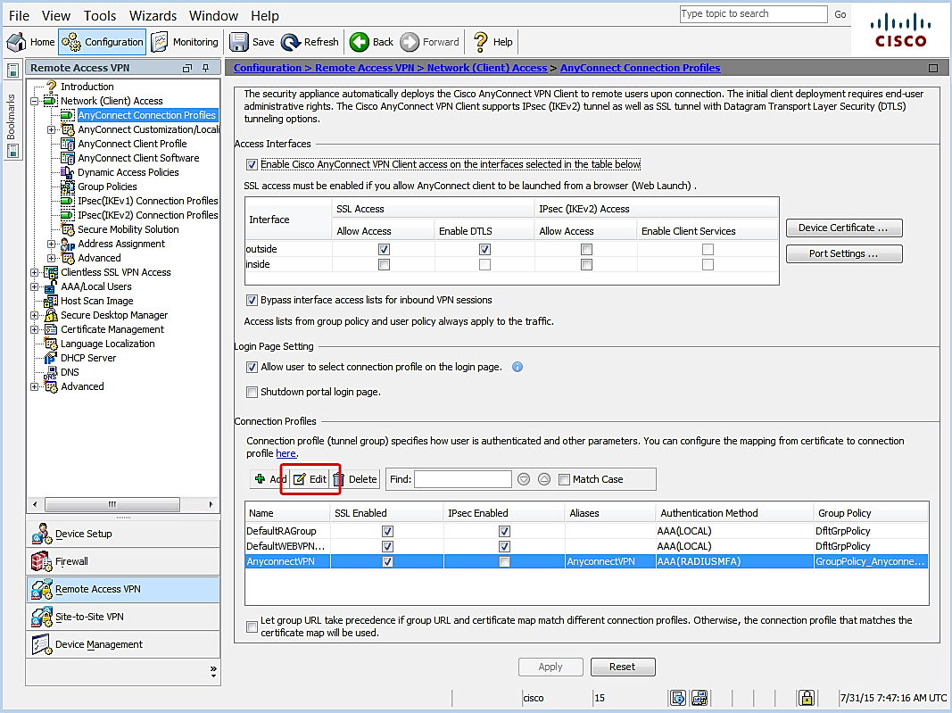

1. The Edit AnyConnect Connection Profile window opens.

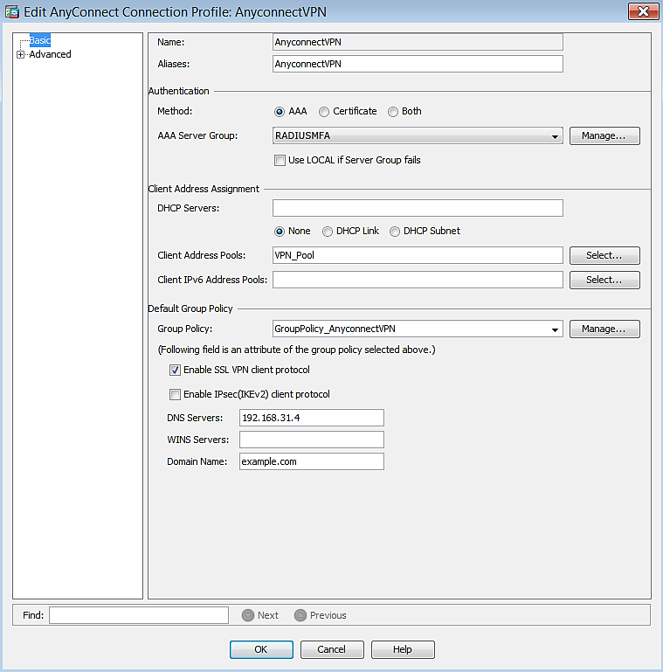

1. Navigate to **Authentication**|**Method**.

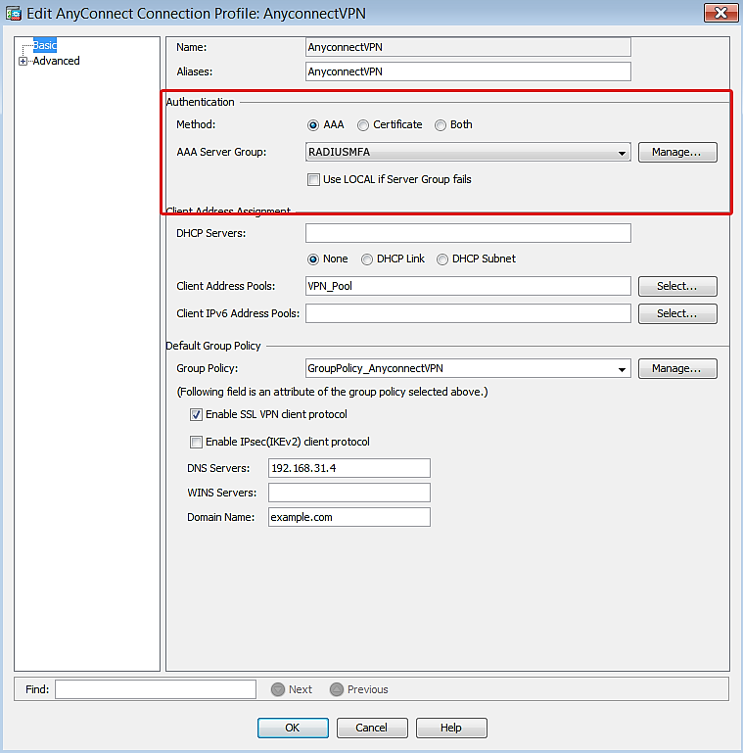

1. Confirm the following:
2. **Method** – make sure **AAA** is selected.
3. **AAA Server Group** – make sure the group created for the MFA server is selected.
4. Click **OK**.
5. Click **Apply** to save the configuration.

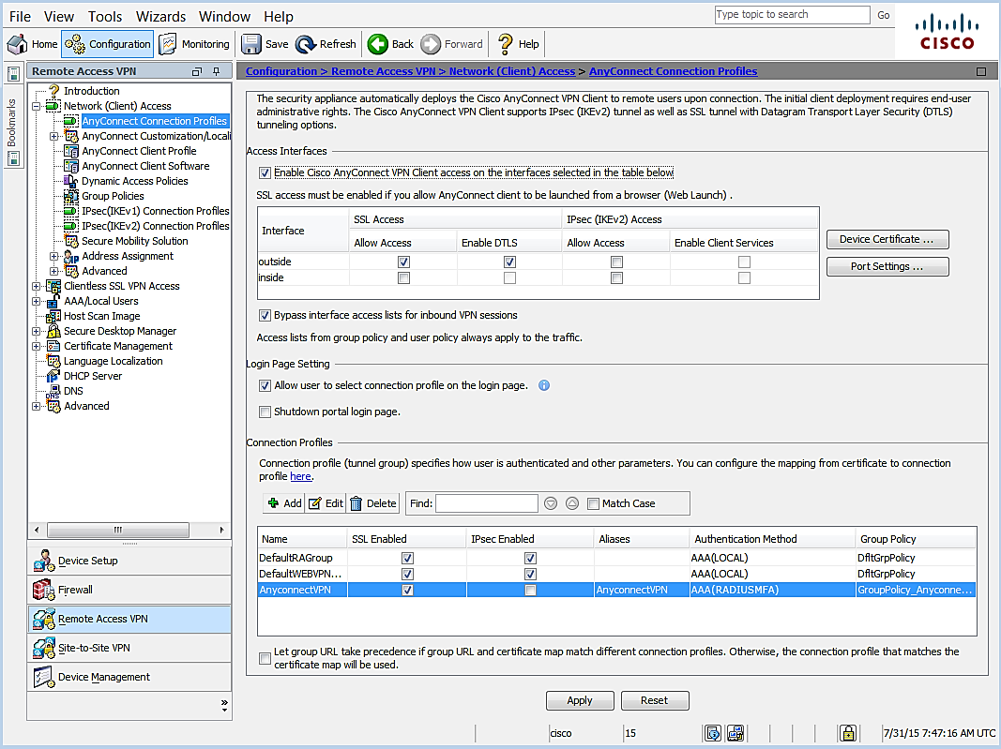

### Configure Timeout

1. Navigate to **Remote Access VPN**| **Network (Client) Access** |**AnyConnect Client Profile**.

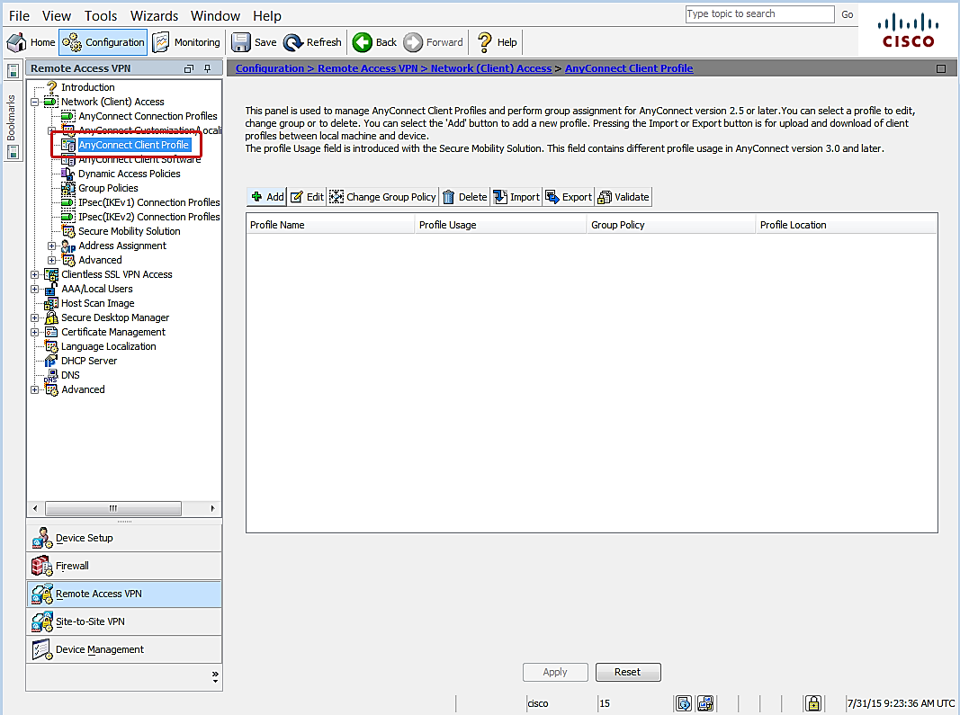

1. Click **Add**.

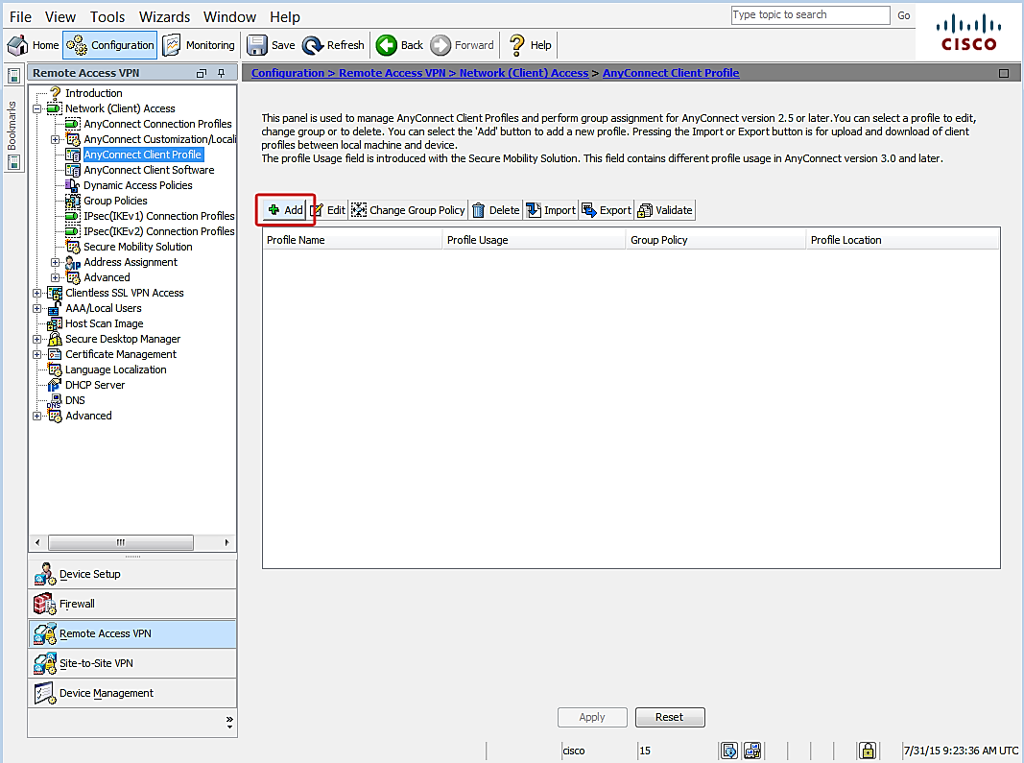

1. The Add AnyConnect Client Profile dialog opens.

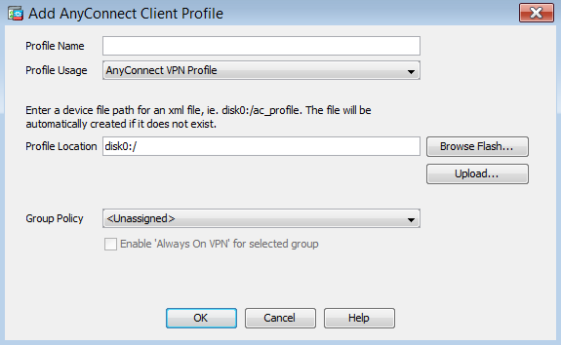

1. Leave the default settings, except for the following:
2. **Profile Name** – enter a descriptive name for the new VPN profile.
3. Click **OK**.
4. Select the VPN Profile that was created and click **Edit**.

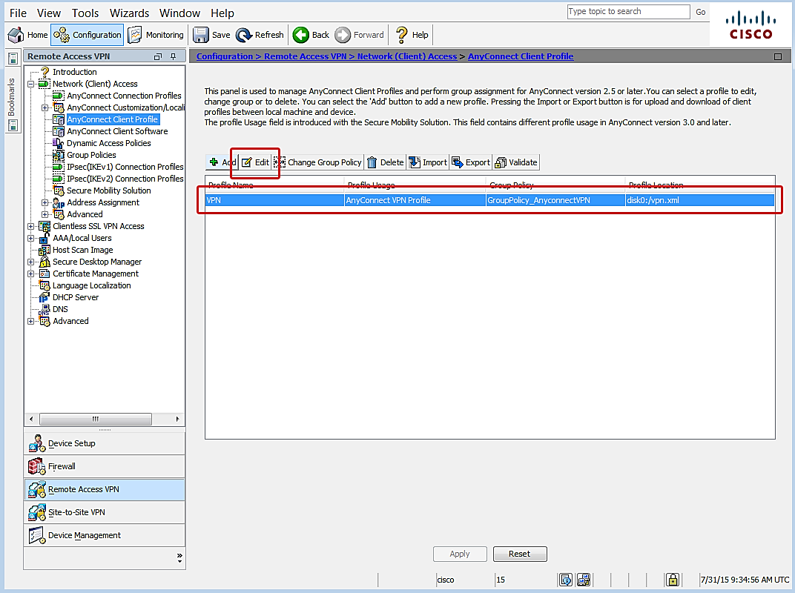

1. The **AnyConnect Client Profile Editor** opens.

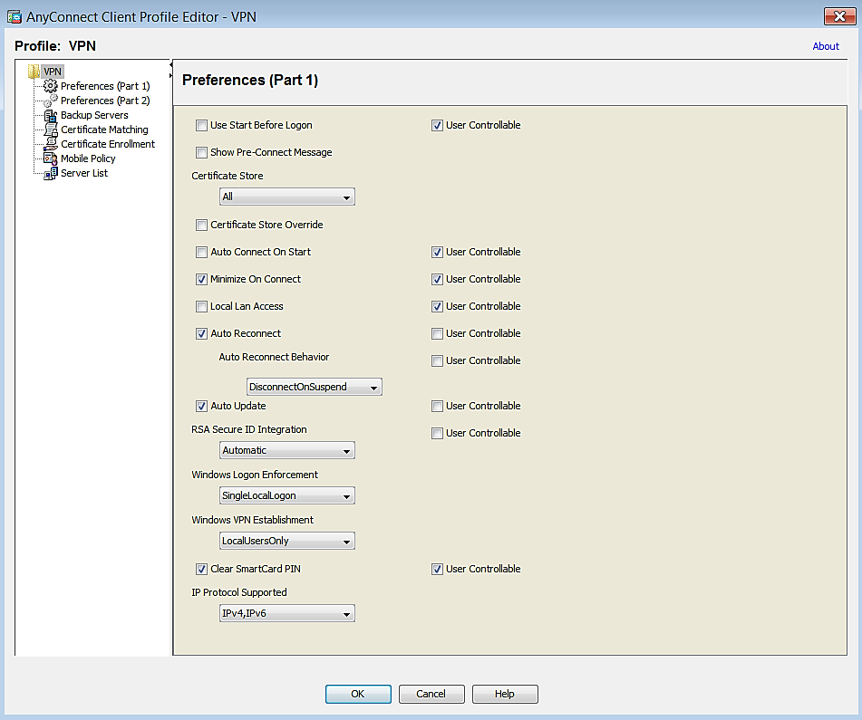

1. Leave default settings except for the following:
2. Click **Preferences (Part 2)**.

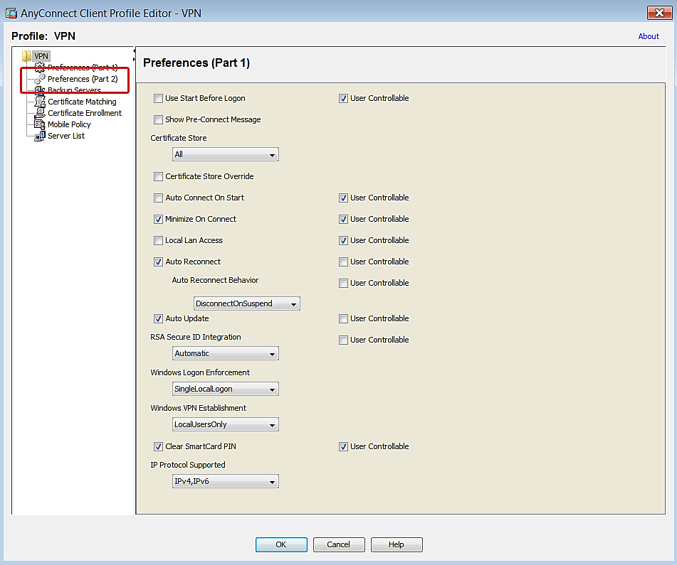

1. Navigate to **Authentication Timeout (seconds)**.

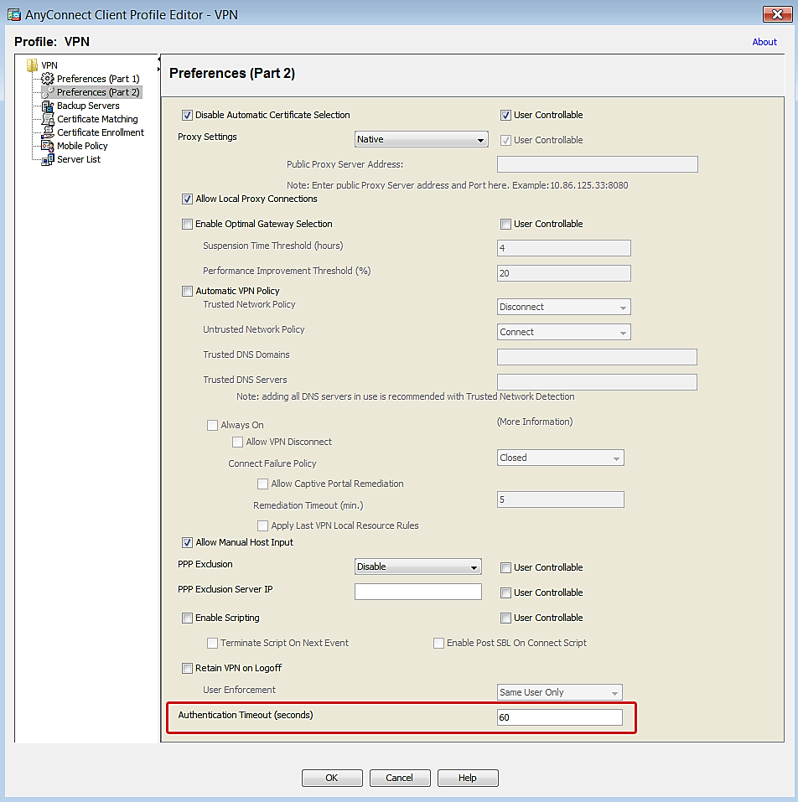

1. Change the value to **60** seconds. Large organizations may require a longer duration.
2. Click **Server List**.

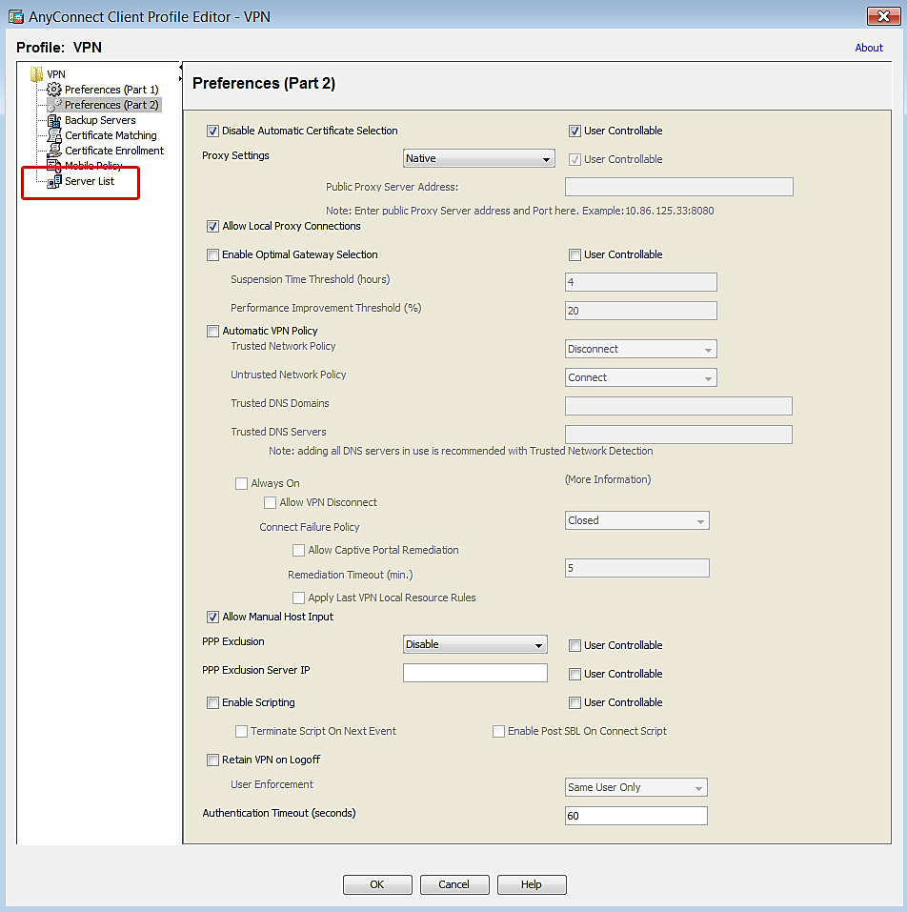

1. Click **Add**.

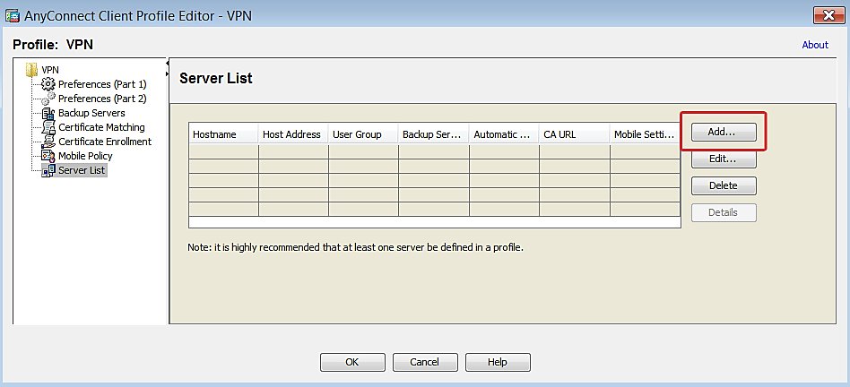

1. Add the Cisco ASA **Host Display Name** and the **FQDN/IP Address** to the profile.

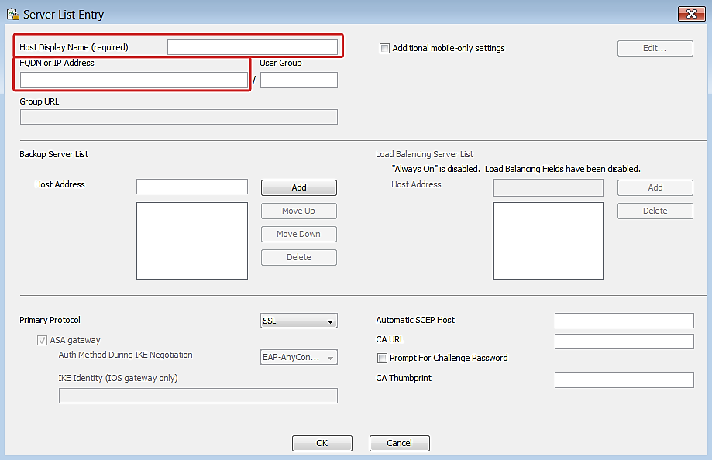

1. Click **OK**.
2. Click **OK** to save configuration changes to the VPN profile.

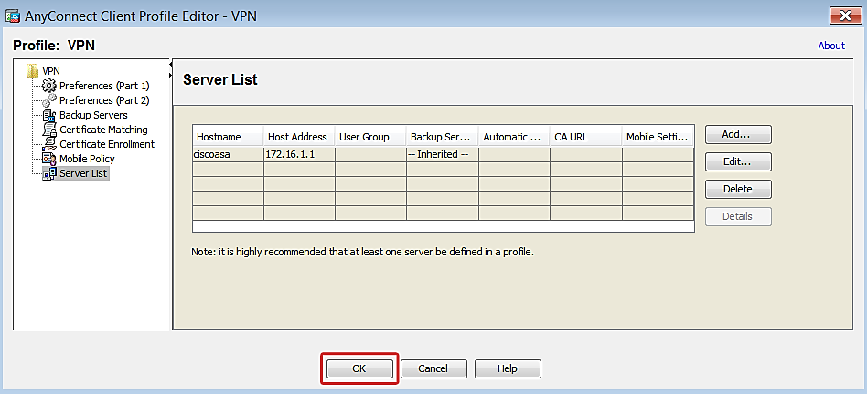

1. Click **Apply** to save the configuration.

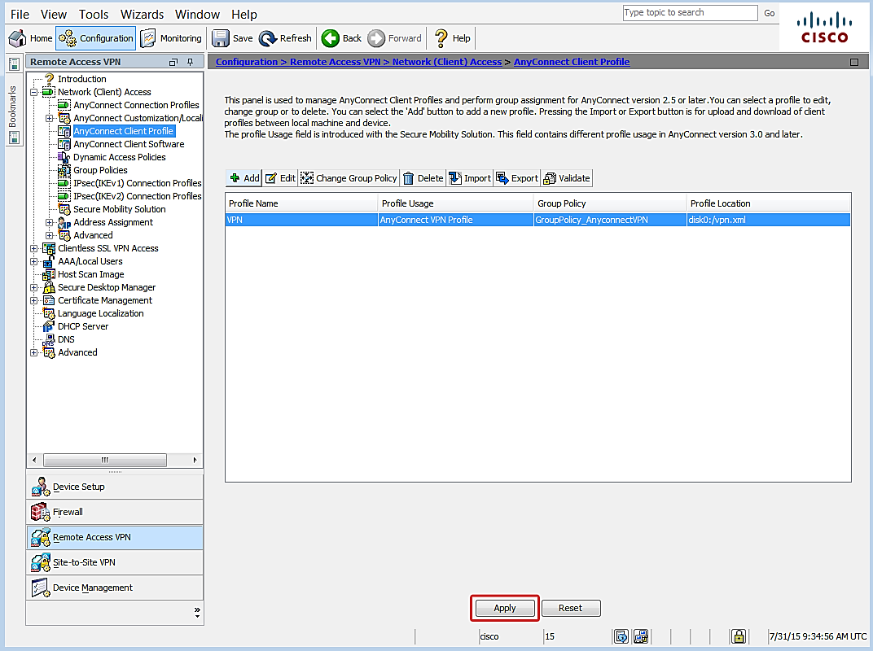

IMPORTANT: The AnyConnect Client Profile you just created must be installed on every device that will use MFA authentication to avoid timeout issues during the login process. One way to accomplish this would be to require clients to connect to the AnyConnect portal and then push the profile automatically.

You have completed VPN appliance setup.

# Step 3: Test Authentication

The topics below are provided to help test authentication with the setup you just completed. Login instructions are provided for each of the authentication methods. Device registration instructions are included for deployments that use the mobile app method for the push notification or OATH token options. If you aren’t going to use mobile app, then skip straight to the Login section.

## Device Registration for Azure Authenticator Users

This step only applies when the mobile app authentication method is used.

The following instructions explain how to activate a user device through the MFA server Users Portal. Please note the following requirements prior to getting started.

### Requirements

* A device with the Azure Authenticator mobile application installed. The application can be downloaded from the platform store for the following devices:
* Windows Phone
* Android
* iOS
* The Azure Users Portal address.
* A computer to access the Users Portal.
* User credentials

### Activate Device

NOTE: Information provided below is current as of the publication date, but is subject to change without notice.

1. Log in to the Azure user portal from a computer.
2. The setup screen displays.

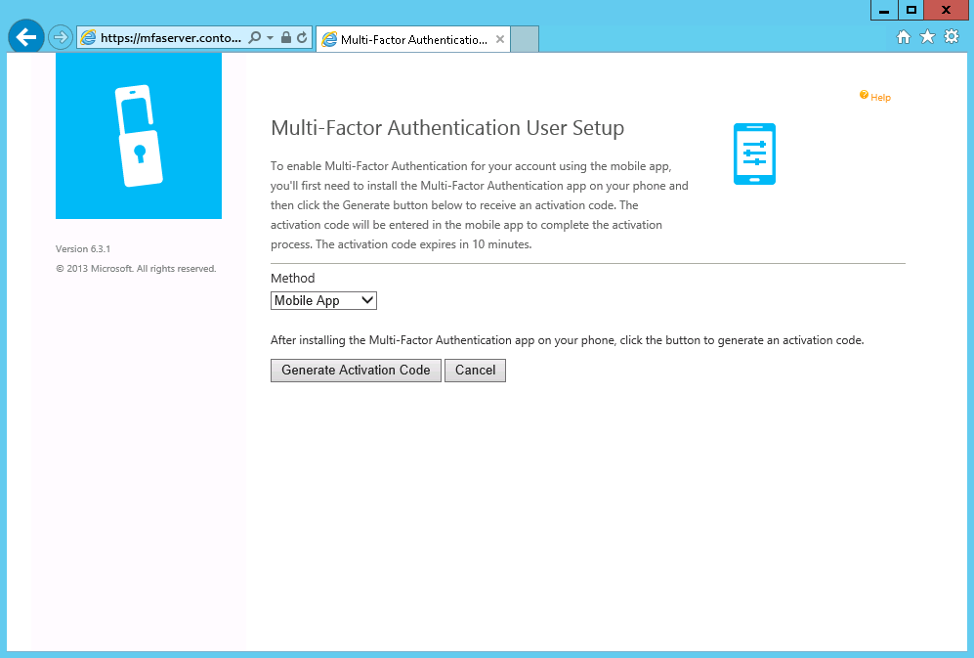

1. Click **Generate Activation Code**.
2. Activation code options will display.

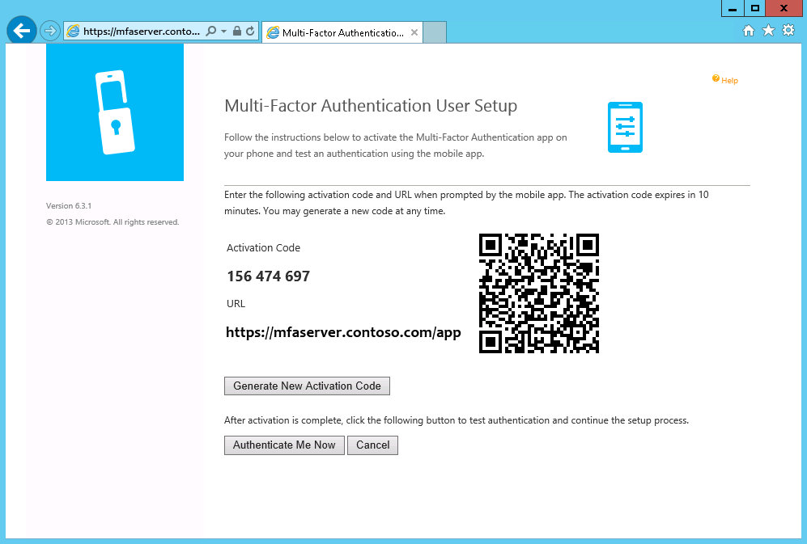

1. Open the mobile authentication app on the user device.

Example:

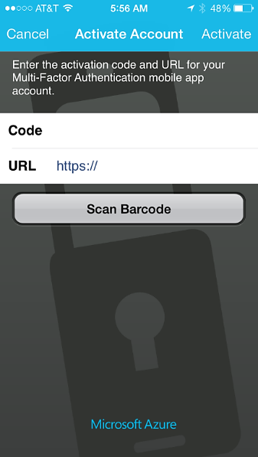

1. There are two options:

* Enter the Activation Code and URL displayed on the Users Portal screen on the device activation screen.
* Use the device to scan the barcode displayed on Users Portal screen.

You have completed device activation.

## Login

Now you are ready to test MFA authentication. Please note the requirements listed below before you start.

General Requirements

* The Cisco AnyConnect VPN Client Profile installed on the device that will access the network
* The IP address or hostname for AnyConnect VPN access
* User credentials

### Phone Call

Required: A phone with the number listed in the AD user account **Mobile** phone attribute.

1. On a computer, launch the AnyConnect client and connect to the network.

Example:

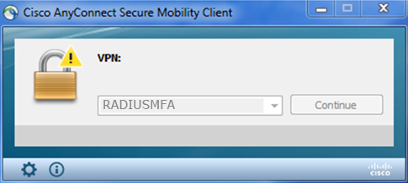

1. Enter user credentials.
2. Check the phone for a call.

NOTE: The call originates in the cloud from the Azure MFA application.

Example:

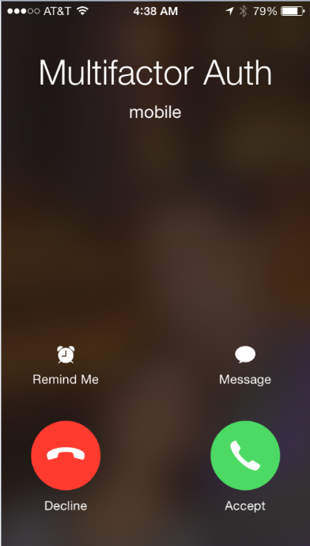

1. The phone call will provide instructions to complete authentication.

### Text Message

Required: An SMS-capable phone with the number listed in the AD user account **Mobile** phone attribute.

#### One-Way Text Message

1. On a computer, launch the AnyConnect client and connect to the network.

Example:



1. Enter user credentials.
2. Retrieve the verification code from the text message.

Example:

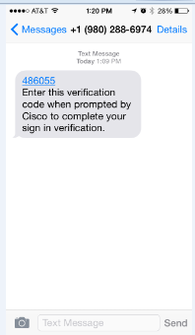

1. Enter the verification code on the response prompt.

Example:

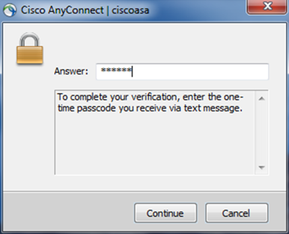

#### Two-Way Text Message

1. On a computer, launch the AnyConnect client and connect to the network.

Example:



1. Enter user credentials.
2. Check the phone for a text message with the verification code.

Example:

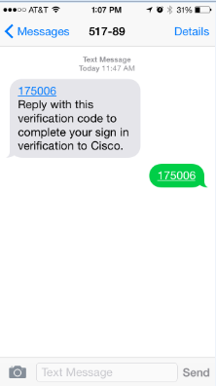

1. Reply to the text message with the same verification code.

### Mobile App

Required: A device with the Azure Authenticator app activated.

1. On a computer, launch the AnyConnect client and connect to the network.

Example:



1. Enter user credentials.
2. Check the device with Azure Authenticator for a prompt.

Example:

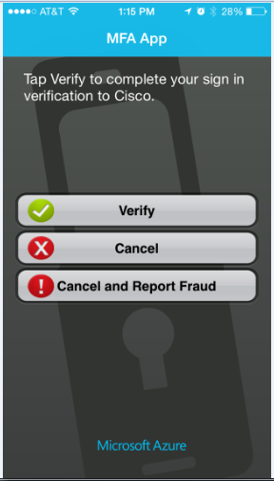

1. Click **Verify**.
2. The authentication application will communicate with the MFA server to complete authentication.

### Oath Token

Required: A device with the Azure Authenticator app activated.

1. On a computer, launch the AnyConnect client and connect to the network.

Example:

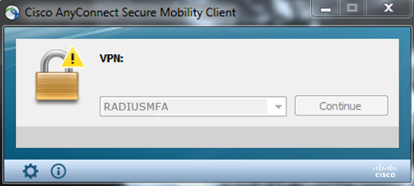

1. Enter user credentials.
2. On the mobile device, open the Azure Authenticator app.
3. Retrieve a verification code from the app.

Example:

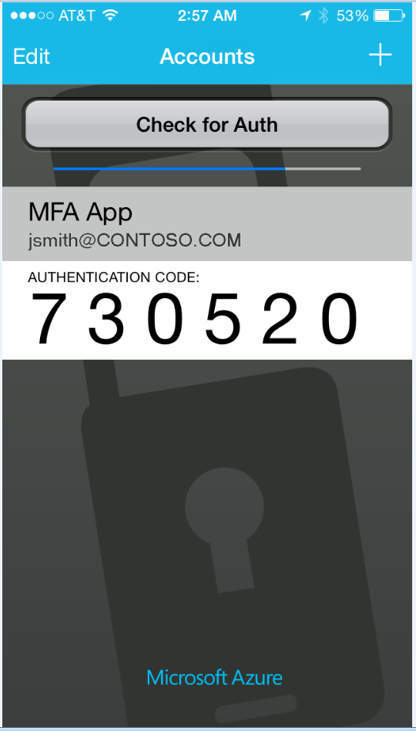

1. Enter the verification code on the response prompt.

Example:

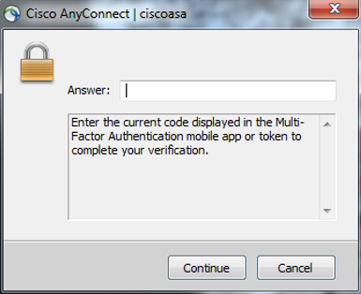

Successful authentication for the VPN connection is indicated by the client. Example:

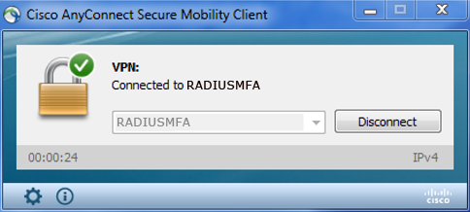

This completes the setup and testing for Azure Multi-Factor Authentication using the RADIUS protocol in a Cisco ASA/AnyConnect VPN appliance deployment.